Experiment #8

Bipolar Junction Transistor (BJT) Amplifier

EENG 275 - W01

Prepared for: M. Fakoor, Professor

New York Institute of Technology

Prepared by: V. Cavalcante, Student

Partnered with: B. Saks, Student

Partnered with: Z. Zhou, Student

New York Institute of Technology

November 22nd, 2019

**Experiment Objectives**

* Determine the DC current and voltages for a single BJT amplifier
* Determine the small signal voltage gain of the amplifier

**Equipment Used**

1- NYIT supplied Lab Kit 1- Digital Multi-meter (DMM)

1- DC Power Supply

1- Function Generator

1- Oscilloscope

1- CA3046 Transistor Array

1- 51 Ω Resistor

1- 470 Ω Resistor

1- 3.9k Ω Resistor

1- 5.6k Ω Resistor 1- 22 µF Capacitor

2- 10k Ω Resistor

3- 100µF Capacitor 3- 1k Ω Resistor

**Results**

**Circuit 8.1 Measurements:**

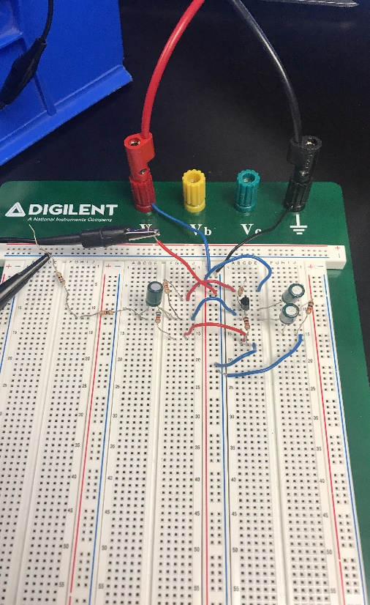

AC and DC Values Circuit

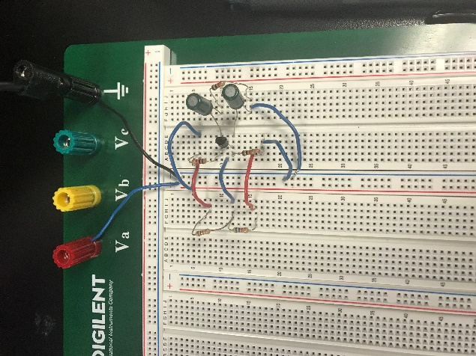

DC Value Circuit

**Circuit 8.1**

|  |  |
| --- | --- |
| **Ieq** | **2.85mA** |
| **Vbq** | **1.8 V** |
| **Vceq** | **4.41 V** |
| **Icq** | **2.85mA** |
| **Veq** | **.702 V** |

|  |  |
| --- | --- |
| **Vc** | **7.44 V** |
| **Vb** | **3.35 V** |
| **Ve** | **2.65 V** |
| **Ic** | **2.62 A** |
| **Ib** | **.02 A** |
| **Ie** | **2.60 A** |

**Conclusion**

* With the use of an extra capacitor the reading for the small signal voltage gain increased likewise.
* Through the use of a function generator we were able to determine that the values were accurately measured with the use of both the DC and AC and DC simultaneously.